Expt. no: 8 Date:

In-house PCB Fabrication: Toner Transfer using Heat

Objective:
- To print the B. Cu layer on glossy paper
- To perform toner transfer using heat
- To fabricate the PCB on a copper-clad board
- To verify the working of the PCB using a multimeter and oscilloscope
Precautions:
- This lab involves hot soldering irons and components. USE EXTREME CAUTION!!!
- The solder used in the laboratory may contain lead. DO NOT breathe fumes generated while soldering. Preferably wear masks.
- Be aware of the location of your soldering iron while it is hot and ensure you place the hot iron in an appropriate holder to prevent heat or fire damage.
- Switch off and unplug soldering tools when not in use.
- Allow the soldering tool to cool before storing.
- This lab involves the use of Ferric Chloride for etching. It is corrosive to skin, eyes, and respiratory tracts. Always wear appropriate personal protective equipment like gloves, face masks, and safety goggles. USE EXTREME CAUTION!!!
- Ferric chloride can stain clothing and surfaces. Avoid contact with skin and work in a well-ventilated area.
- Spent ferric chloride solution should be neutralized and disposed of according to local regulations. Dilute the etching solution with water as much as possible before disposing in a carefully chosen area that does not pose any danger to the environment. Do NOT flush the solution in the sink/ drain.
- While an effective etching agent, ferric chloride demands careful handling.
- Wash your hands thoroughly with soap after performing the etching and soldering procedure.
Equipment:

Instruments: Oscilloscope, Digital Multimeter, Fume Extractor
Components:
Sr. No. | Items | Quantity
1 | Step-down transformer | (enter quantity)
2 | Pin Headers | (enter quantity)
3 | Diodes 1N4007 | (enter quantity)
4 | Resistors (2.2K) | (enter quantity)
5 | Screw Terminals | (enter quantity)
6 | Capacitors (470 uF) | (enter quantity)

Other material:
Sr. No. | Items | Sr. No. | Items
1 | Copper-clad Board (3” X 3”) | 8 | Ferric Chloride powder
2 | PCB Cutter | 9 | Flux
3 | Scrubber, IPA solution | 10 | Soldering iron
4 | Permanent marker to draw track pattern | 11 | Helping hand clamps/ Tack
5 | Tissue paper/ cotton | 12 | Face mask, gloves
6 | Soldering wire | 13 | Brass wire sponge for tip cleaning
7 | Flat-bottom container of size to fit the PCB, half-filled with water | 14 | Wet Sponge for tip cleaning

Procedure to perform the experiment:
- Use the edge-cut, drilled PCBs from the Wegstr machine.
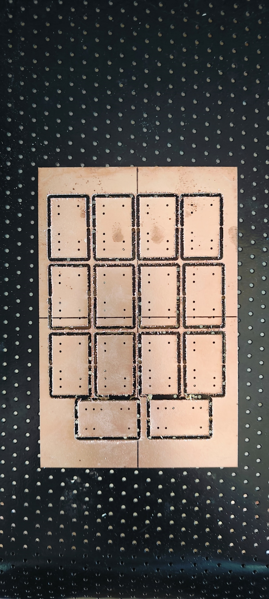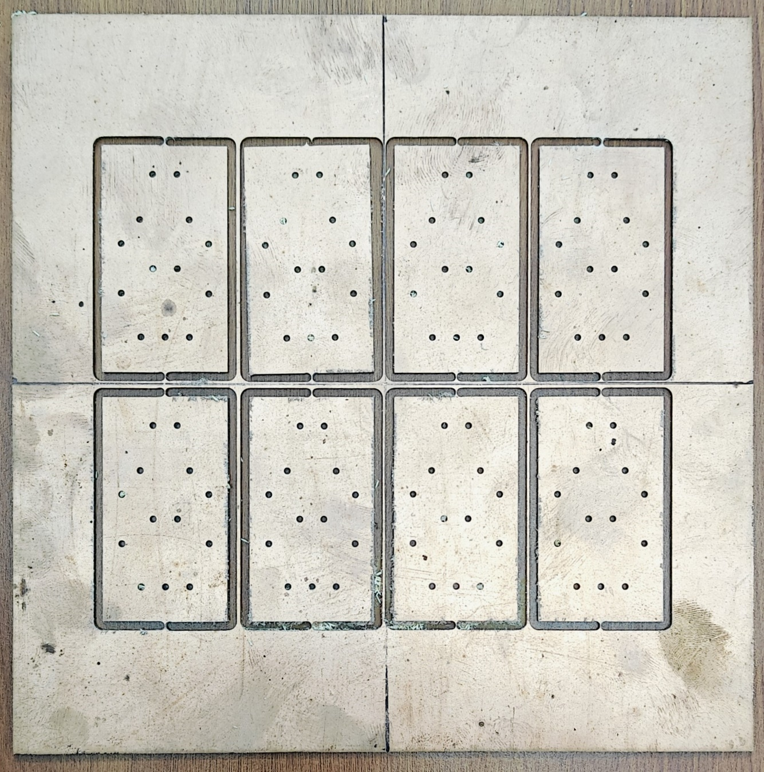
Fig. 9.1 HWR drilled and edge-cut board Fig. 9.2 CT-FWR drilled and edge-cut board

- Clean the copper side of the board using a scrubber to remove the oxide layer, and then with soft tissue paper and IPA.
- Use a Laser printer and a glossy photo paper sheet to print the Back copper gerber pdf print using the “Actual size” setting.
- Cut the printout to an appropriate size.
- Clean the copper side of the PCB using a scrubber to remove the oxide layer, and then with IPA.
Note: If the PCB is not cleaned well, the oxide layer will remain in between the copper and the toner and toner will not get transferred well onto the copper. As a result, the toner circuit will come off with the glossy paper. Your print on glossy paper and the copper-clad board will get wasted.
- Place the print-out on the cleaned PCB with toner facing the copper. Make sure the circuit artwork on the paper is properly aligned with the drill holes on the PCB.
- Transfer the toner from the print-out to the copper-clad PCB using heat, use the clothes iron for this. Gently press and glide the corner of the iron on the print, with maximum temperature setting. Do this for a maximum of 8-9 minutes.
Note: If the entire iron is placed on the print for too long at high temperatures, the copper layer will get too hot and bubble up, causing separation from the FR4 material.
- Put the PCB in a container with water, and wait approximately 10-15 minutes for the glossy paper to separate from the PCB. Clean the PCB such that no paper remains on the exposed copper.
Note: Make sure not even a slight trace of paper remains on the areas to be etched out. If the paper is not removed, the etchant will not reach the copper, and etching will not take place. Therefore, let the PCB dry, and observe the PCB very carefully.
- Wear gloves. Make an etchant solution by adding Ferric Chloride to water in a plastic container having a size slightly greater than the size of the PCB. The solution should look muddy, not transparent.
- Insert the PCB into the etchant. Keep stirring the PCB inside the container to create friction of the solution against the PCB surface. This speeds up the process of etching.
- Observe the copper being etched away starting from the edges towards the center of the board. Keep checking if the copper is completely removed by holding it against the light.
- Once all the uncovered copper is etched and verified, remove the PCB from the solution container and wash it with tap water.
- Use a scrubber to scrub away the toner. Make sure that it is removed completely. Clean the board with IPA and tissue paper. The PCB should now have shiny tracks and pads according to the PCB layout planned.
- Solder the components according to the soldering procedure outlined in experiment no. 1.
- Test the PCB for continuity. Observe the output waveform and calculate the value of the ripple factor.
Circuit Diagram:

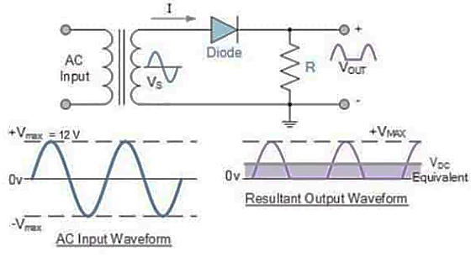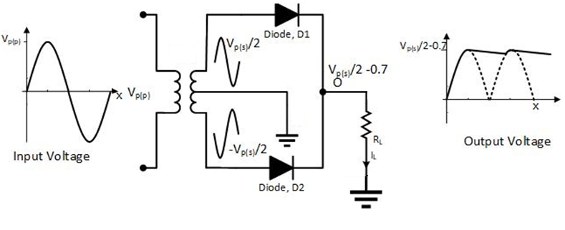
Fig. 9.3 The Half Wave Rectifier Circuit Fig. 9.4 The Center-Tapped Full Wave Rectifier Circuit
with Capacitor Filter

Implementation:
Fig. 9.5 Board after toner transfer using heat
Fig. 9.6 Board after etching
Fig. 9.7 Board after toner cleaning
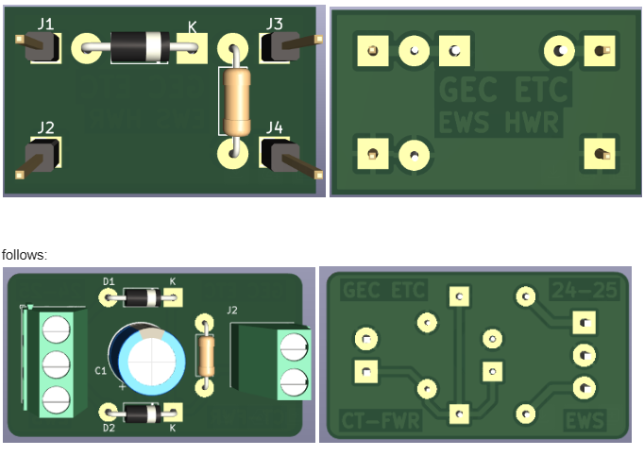
Fig. 9.8 Component-side of HWR using KiCAD Fig. 9.9 Component-side of fabricated HWR

Fig. 9.10 Solder-side of the HWR using KiCAD Fig. 9.11 Solder-side of fabricated HWR

Fig. 9.12 Component-side of CTFWR using KiCAD Fig. 9.13 Component-side of fabricated CTFWR

Fig. 9.14 Solder-side of the CTFWR using KiCAD Fig. 9.15 Solder-side of fabricated CTFWR
Fig. 9.16 Plot of the output waveform: HWR (on a graph page)
Fig. 9.17 Plot of the output waveform: CTFWR (on a graph page)

Ripple Factor Calculations:

Results:
- Measured value of R = ______________
- Ripple Factors:
 | Breadboard | Copper-clad board
HWR
CT-FWR

Challenges: (write the challenges you faced and overcame, more the challenges you overcome, more the marks, use Grammerly, not ChatGPT, remove this text)

Conclusion: The following objectives were achieved:
- B. Cu layer was printed on glossy paper.
- Toner transfer was performed using heat.
- HWR and CTFWR PCBs were fabricated on a copper-clad board.
- The working of the PCBs was verified using a multimeter and oscilloscope

